
Janvrin School
Jersey Premium Strategy 2025

School overview
Detail | Data
School name | Janvrin School
Number of pupils in school | 318
Proportion (%) of Jersey Premium eligible pupils | 41%
Academic year/years that our current Jersey Premium strategy plan covers | 2025-26
Date this statement was published | January 2025
Date on which it will be reviewed | November 2025
Statement authorised by | Mark Chipperfield  Leah Gabbiadini
Jersey Premium lead | Mark Chipperfield  Leah Gabbiadini
Funding overview
Detail | Amount
Jersey Premium funding allocation this academic year | £212,000
Total budget for this academic year | £212,000

Part A: Jersey Premium strategy plan

Statement of intent
At Janvrin School, we aim to align levels of achievement in reading, writing and maths between JP and non-JP children, both within the school and in comparison to all island averages. We offer a rich and balanced curriculum, to support every child in our community to be the best they can be.

Our school has a high level of JP children due to the town catchment and social economic climate. When the children start school in EYFS, on entry data is lower than island average, but when the children leave us in Yr6, levels are in line or above island average. We support this by specifically focusing our funding on quality teaching, to ensure positive impact for every child, so they can meet their full potential and make progress.
It is clear from our data that as children progress through the school, Janvrin JP children achieve better or equivalent to Non-JP child in the 3 core subjects.
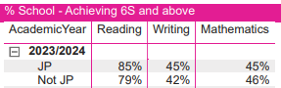
The school is dedicated to providing high quality teachers and support staff who secure quality experiences and learning opportunities. Our teaching and non-teaching staff are positive and committed, this is evident through our high level of staff retention. Our subject leaders work on improving outcomes for all by monitoring and tracking subjects, to ensure the curriculum provides children with exciting lessons and resources beyond their lived experience. Our progression of skills enable children to deepen their understanding of concepts over time.
As a school we recognise the rise in numbers of children with complex needs across the school, which can present barriers to learning and achievement. Teaching staff, the pastoral team, families and outside agencies work together to ensure these children are included and understood, identifying their needs and ensuring support is in place to make them successful. They ensure children reach their potential through fostering positive relationships, seeking support and guidance where there are barriers to learning.
Our strategy is focused on identifying what each child needs to be successful and achieve. In order to do this we:
- Employ high quality teaching and support staff.
- Offer experiences for children to enhance their lived experience.
- Employ specialist teachers to ensure a broad and balanced well taught curriculum.
In recent years, we feel our targeted focus on staffing, curriculum resources, enrichment opportunities and mental health, has created a long-lasting culture through continuity and consistency that we wish to build on in 2025. All our work through the JP strategy supports progress and attainment for all of our community within Janvrin School.

Challenges

This details the key challenges to achievement that we have identified among our pupils eligible for Jersey Premium funding.
Challenge number | Detail of challenge
1 | Levels of attainment:  Internal assessments on entry show our children are below where they should be (see below). Across the school we want to continue to align reading, writing and maths data with all island averages.  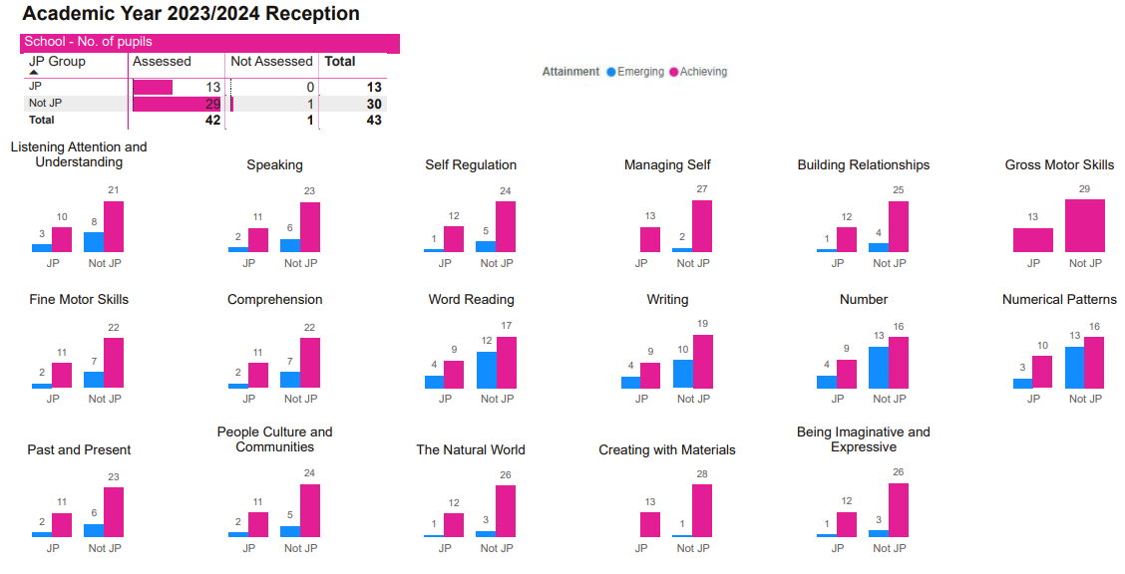
2 | Social, emotional mental health concerns and support:  Some children’s SEMH profile inhibits their ability to access the classroom environment due to behaviour of concern and safety.
3 | Quality teaching and learning for all pupils:  Investing in highly skills teachers, CPD and resources to support the progress and attainment of every child.
4 | Enrichment:  Many of our children have limited experience of our island due to financial implications. This impacts access and specialist instructors; therefore we prioritise this in the funding.

Intended outcomes
This explains the outcomes we are aiming for by the end of our current strategy plan, and how we will measure whether they have been achieved.
Intended outcome | Success criteria
To align levels of achievement in reading, writing and maths between JP and non-JP children both within the school and in comparison to all Island’s school averages. | Rigorous half termly assessment highlights progress and areas of concern. Internal moderation supports teacher judgements. Children to gain age-appropriate skills and knowledge, building on prior knowledge and understanding.
To achieve and sustain an improved level of wellbeing for all pupils in our school. | Support progress in social and emotional wellbeing, as this impacts on academic achievement. Children are either supported through on-going internal support or signposted to external support and agencies as needed. Children develop the ability to be able to talk about their emotions and regulate.
To develop staff and invest in hight quality teaching | Continue to support and develop current staff. Recruit more SEND staff to support children throughout the school. Invest in CPD opportunities. Develop staff timetables for interventions for children highlighted during assessment.
To offer enrichment activities inside and outside of school to support progress and attainment. | Contribute towards the cost of trips and employ specialist teachers so the children get experiences they may not access outside of school.

Activity in this academic year
This details how we intend to spend our Jersey Premium this academic year to address the challenges listed above.

Teaching (for example, CPD, recruitment and retention)
Budgeted cost: £100,000
Activity | Evidence that supports this approach | Challenge number(s) addressed
Reading Teacher:  Reading booster sessions 3 morning per week | Our internal tracking of reading levels identifies children that require additional support. Assessments show that disadvantaged pupils receiving intervention make good progress. | 1,2,3
Music Teacher:  Our music specialist is full time. This enables her to work with identified small groups of children or 1-1 as needed in instrumental or musical responses and instrumental access. Her work also includes the development of 2 choirs who rehearse each week and ensuring that they access regular opportunities to perform publicly and outside of the school. This is outside of her curriculum teaching time. | The vast majority children who have undertaken extra-curricular music opportunities have shown, in the long term, increased improvements in their learning dispositions: better resilience and commitment to task, positive collegiate and cooperative behaviours with peers and staff and generally happier and more confident dispositions. | 1,2,4

Targeted academic support (for example, tutoring, one-to-one support structured interventions)
Budgeted cost: £65,000
Activity | Evidence that supports this approach | Challenge number(s) addressed
LSA in class AM:  12 hours a week in class to support for Reading, writing and maths | Children need extra support in class to access learning. LSA will support children through targeted intervention and in class support. The interventions are highlighted through assessment. | 1,2,3
LSA PM:  Yr6 for targeted interventions reading, writing and maths | The LSA is trained in targeted interventions. They work closely with the class teacher to address targets for individual children. | 1,2,3
Nurture Group:  A targeted intervention run by two members of staff for children across the school to support SEMH needs. | This resource supports a number of children who presented with significant SEMH needs in their Primary careers. It provides a nurturing, safe space to address their primary needs. | 1,4
MNP:  As a school we have invested in a robust scheme to support the teaching of maths. Last year the level of attainment in maths was lower than previous years. | This is a resource which is used across the school from EYFS-yr6. Teachers can access planning and resources which support the teaching and learning of maths. | 1,2,3
Reading:  Invest in phonics books to support reading at home. | Our assessment shows children in KS1 & 2 need access to more texts that are linked to our phonics scheme to support children build confidence. (Oxford University Press) | 1,2,3,4

Wider strategies (for example, related to attendance, behaviour, wellbeing)
Budgeted cost: £47,000
Activity | Evidence that supports this approach | Challenge number(s) addressed
Enrichment:  To develop and expand children’s experiential knowledge of their Island community, culture and heritage and relate this to their more abstract learning in school.  All pupils from Nursery-Y6 will have targeted and timetabled out of school ‘visits’ and activities that will relate closely to their current planning and curriculum. This will include Activities week (Yr6) as well as Forest Friends for FS children and cost of transportation for all school trips. | The experiential work and visits have shown an improvement in the quality of work that children can subsequently produce from their visits and trips.  For all children this enhances their increased knowledge of Jersey, it’s history and their place in their community. | 1, 2, 3, 4
Lunchtime:  Invest in resources and staff to support and develop outdoor play. | Investing in lunchtime provision and staffing has an impact on all areas of the school day, including learning and behaviour. | 1,2,3

Total budgeted cost: £212,000

