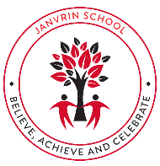  JANVRIN SCHOOL  Autumn Term (2) 2025  Dear Parents and Carers,  A big welcome back to school for the next half term! We will be continuing to make this year extra special and have lots of brilliant activities and special events taking place. We also have an enriched and stimulating curriculum planned that will support your children to achieve their full potential.  Homework:  Must:  - Read Library book and record in Reading Log for Mondays.  - Access TTRS independently at least 3 times a week.  - Learn Christmas Poem of choice off by heart for recital!  - Learn Y5&6 word list.  Should:  - Access Reading Eggs independently.  - Access Rollama independently.  Could:  - Complete at least 1 home-learning project from the topic list.  6LB – l.lebrocq@janvrin.sch.je  6G – s.george@janvrin.sch.je | 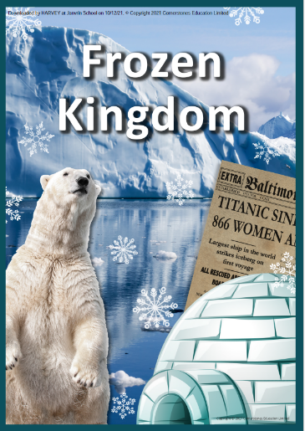  Frozen Kingdom  Topic Overview  Frozen Kingdom brings you into the worlds of the polar regions and explores all things cold, icy and ever-changing. Pupils will learn about how an iceberg and cruise liner made devastating history, and learning about the wonders of the artic and Antarctic.  Key trips/experiences:  - Visitor from the JEC.  - Watch ‘Aladdin’ at Haute Vallee School.  - School Deco Day.  - Christmas Church Service.  - Watch ‘The Boy in the Striped Pyjamas’ movie together.  - Live Electrical Demonstrations to Year 2 pupils in Science.
Mathematics | English
Our mathematical chapters for this term are:  Fractions:  - Adding, subtracting, multiplying and dividing fractions  - Simplifying fractions and then moves on to comparing and ordering fractions  - Working with basic fractions and mixed numbers  - Add and subtract fractions with different denominators, including mixed numbers  - Bar model diagrams are incorporated to support pupils' understanding before moving on to multiplication and division. Pupils will be required to divide fractions by whole numbers and will explore different methods.  Decimals:  - Read and write decimals using Base 10 materials before moving on to dividing and multiplying decimals by 1-digit numbers with no regrouping or renaming.  - Write fractions as decimals using division and pictorial methods before looking at multiplying fractions that involve some regrouping and renaming by 1-digit numbers.  - Dividing decimals again, this time when regrouping and renaming with 1-digit numbers is required  - Multiplying and dividing decimals by 2-digit numbers, which involves regrouping and renaming, using a variety of methods and strategies, including: number bonds, the worded method (writing down a problem in words and numbers), long division and the column method.  Measurements:  - Converting units of measurement using fractions and decimals.  - Converting units of length and distance, followed by exploring units of mass, volume and time. | Class Reader:  The Boy in the Striped Pyjamas by John Boyne  Writing focuses to be covered this half term:  - Non-Chronological Reports  - Playscript  - Haiku Poetry  Spelling, punctuation, and grammar (SPaG) skills covered this half term:  - Passive verbs  - Colons and semi-colons between independent clauses  - Bulleted lists  - Relative clauses  - Expanded Noun Phrases  - Commas
P.S.H.E | Science
This half term, our topic is ‘Relationships’. We will be discussing different types of relationships and specifically pressure from peers and social media. Also, we will look at challenging others and managing conflicts. We will be using our oracy skills and planned oracy tasks to elevate our learning within these lessons.  To end the half term, we will be using a ‘No Outsiders’ text to encourage discussion and reflection. | In Science this half term, Year 6 will be learning about Changing Circuits (electricity). They will understand how electrical circuits work, the symbols used and how electricity is used safely in everyday life. They build and test simple series circuits, exploring how changes (like adding more bulbs or cells) affect brightness or volume. Learners also investigate conductors and insulators, discovering which materials allow electricity to flow. The unit encourages practical experimentation, problem-solving, and links to real-world applications of electricity.  Oracy Fab Finisher  Outcome: Live Demonstration  Audience: Younger peers  Purpose: to share and entertain
French | R.E
In French we will be:  - Recapping months of the year.  - Recapping weather phrases  - Recapping key conversations questions and answers.  - Learning about transport.  - Using the verb ‘aller’ to say and write sentences about transport. | Religion focus: Thematic Unit (Non-religious)  Key Question: Why do some people believe in God and some people not?  Make sense of belief:  • Define the terms ‘theist’, ‘atheist’ and ‘agnostic’ and give examples of statements that reflect these beliefs  • Identify and explain what religious and non-religious people believe about God, saying where they get their ideas from  • Give examples of reasons why people do or do not believe in God  Understand the impact:  • Make clear connections between what people believe about God and the impact of this belief on how they live  • Give evidence and examples to show how Christians sometimes disagree about what God is like (e.g. some differences in interpreting Genesis)  Make connections:  • Reflect on and articulate some ways in which believing in God is valuable in the lives of believers, and ways it can be challenging  • Consider and weigh up different views on theism, agnosticism and atheism, expressing insights of their own about why people believe in God or not  • Make connections between belief and behaviour in their own lives, in the light of their learning.
Music | Art & D.T
It’s beginning to look a lot like Christmas… Firstly, huge congratulations to the choir of children who performed at the Opera house a few weeks ago. You were absolutely amazing and I was incredibly proud of you all representing our school. This half term the whole of year 6 become the choir and we will be doing some carol singing out of school at the Coop once again (date to be confirmed). We have a large amount of Christmas songs to learn over the next few weeks and the children are already excited about the ones we have chosen. This year we are delighted to celebrate Christmas with songs in Polish, Portuguese, Romanian and Fillipino alongside our usual favorites. You are invited to share in the celebrations and sing with all of Key stage 2 at the St Helier Methodist Church on the last day of term Thurs 18th Dec at 1.30pm . It was amazing last year and a wonderful way to start the holidays. | Art  Artist Focus: Frederic Edwin Church  Outcome: Northern Lights Landscape  Medium: Chalk  This half term, pupils will learn about this famous art in history, the northern lights piece he created and aim to practise techniques to replicate their own landscape.
P.E | Computing
During their PE lessons the children will be focused applying their skills and understandings to small sided games of Netball and Volleyball. We will touch on the skills of group balance, climbing and landing. Whilst they will also continue to work on fundamental skills such as throwing, catching, dribbling and striking.

