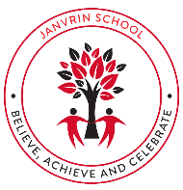  JANVRIN SCHOOL  Spring Term 2026  Dear Parents and Carers,  We will be continuing to make this new year and half term successful and extra special. We also have an enriched and stimulating curriculum planned that will support your children to achieve their full potential as they complete their final term of Year 4!  Homework:  Must:  - Read Library book and record in Reading Log for Mondays.  - Access TTRS independently at least 3 times a week.  - Learn Year 3 & 4 statutory spelling list.  Should:  - Access Reading Eggs independently.  - Access Rollama independently.  Could:  - Complete 2 projects from the topic list  4M – s.mallon@janvrin.sch.je  4H – s.hargreaves@janvrin.sch.je | 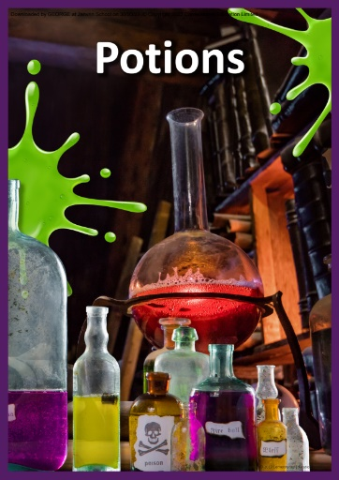  Potions  Topic Overview  Potions is a topic where children can experiment and create exciting concoctions, potions and elixirs. Additionally, we will focus on how individuals such as Florence Nightingale helped to improve the conditions of patients in the Victorian Era through their very own magical methods of the time. Children will have plenty of opportunities to get creative, through their writing, artwork and more!  Books for Topics  Books for Topics is a useful website that shows a range of books for your chosen topic. Here we have attached a link specifically about some areas of our learning this half term. Please feel free to have a browse:  https://www.booksfortopics.com/booklists/topics/science-maths-computing/celebrating-science/  https://www.booksfortopics.com/booklists/topics/history/victorians/  Reading Eggspress  Please make use of the library function on Reading Eggspress as this contains lots of books relating to our topic this half term. There are useful filters for age-range books to ensure you find suitable texts for your child.  Guided Reading / Oracy Fab Finisher  Outcome: Talk to entertain – discussions around Wonder  Audience: Peers and adults  Purpose: To inform
Mathematics | English
Our mathematical chapters for this half term are:  Further Multiplying and Dividing.  - Multiplying three numbers  - Multiplying multiples of 10, 100  - Multiplying 2-digit and 3-digit numbers with and without renaming  - Dividing 2-digit and 3-digit numbers  - Solving word problems  Graphs  - Drawing and reading pictograms, bar graphs and line graphs.  Fractions  - Counting in hundredths  - Writing in mixed numbers  - Showing mixed numbers on a number line  - Finding equivalent fractions  - Simplifying mixed numbers and improper fractions  - Adding and subtracting fractions | 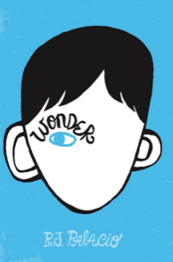  Class Reader:  Wonder by RJ. Palacio  Writing focuses to be covered this half term:  - Informal letters  - Instructions  - Playscripts  Spelling, punctuation, and grammar skills covered this half term:  - Use conjunctions, adverbs and prepositions to express time and cause  - Extend the range of sentences by adding conjunctions, including when, if, because, although  - Propose changes to vocabulary  - Use present perfect form verbs in contrast to the past tense  - Use fronted adverbials  - Show possession by using apostrophes
P.S.H.E | Science
This half term, our topic is ‘Relationships’. We will be focusing on identifying positive healthy friendships, how to seek support with relationships if feeling secluded, online safety and identifying bullying. We will be using oracy to elevate our PSHE learning throughout this sequence of learning.  To end the half term, we will be using a ‘No Outsiders’ text, which illuminates an important social story and message. This will encourage discussion and reflection. | Within Science we will be learning about ‘Habitats and Survival.’.  We will be learning to classify living things based on their characteristics, using scientific keys to identify plants and animals.  We will learn about food chains as well as different habitats such as forest, desert, and frozen habitats, comparing the characteristics of each setting as we understand factors that lead to environmental changes.  At the end our topic, we will have a ‘Fab Finisher’, whereby the children will create their own group poster or PowerPoint to present to another group/the class.
Languages | R.E.
In French, we will be continuing to practise our ‘Conversation Rapide’ questions each lesson.  We will be learning about:  - Parishes in Jersey  - Habitats in Jersey  - Habitats in France  - Rooms in a house  Learn a Language focus for this half term is: Mauritian Creole. | Religion: Hinduism  Key Question: What do Hindus believe that God is like?  Understand the impact:  - Describe how Hindus show their faith within their families in Britain today (e.g. home puja).  - Describe how Hindus show their faith within their faith communities in Britain today (e.g. arti and bhajans at the mandir; in festivals such as Diwali).  - Identify some different ways in which Hindus show their faith (e.g. between different communities in Britain, or between Britain and parts of India).  Make sense of belief:  - Identify the terms dharma, Sanatan Dharma and Hinduism and say what they mean.  - Make links between Hindu practices and the idea that Hinduism is a whole ‘way of life’ (dharma).  Make connections:  - Raise questions and suggest answers about what is good about being a Hindu in Britain today, and whether taking part in family and community rituals is a good thing for individuals and society, giving good reasons for their ideas.
Music | Art & D.T.
In music we shall be developing our music theory skills. Through games and activities, we shall learn how to read more complex music from the musical stave. We need to learn about duration, pitch, rhythm and be able to confidently describe the notes they see and be able to play rhythms accurately. We will celebrate the lunar new year playing music with the ‘pentatonic scale’ on a variety of instruments as a class ensemble to create Chinese inspired music working on our improvisation skills. | Art  Artist Focus: Evelyn De Morgan  We will be learning about the famous artist Evelyn De Morgan.  We will be practicing creating detailed collages using various forms of media (newspapers, magazines) to create landscape images, focusing on aspects such as background and foreground.  Our final piece will focus on creating a collage displaying a magical workshop with the children as alchemists creating potions – an opportunity they will have as the children mix magical ingredients together to concoct their very own elixirs!
P.E. | Computing
This half term, the children will be applying their skills and understandings to small sided games of Pok a tok and American tag ball. The children will continue to develop their body control skills by participating in activities that involve balance and others that challenge their climbing and landing skills. | In Year 4, pupils develop their programming skills further by learning about repetition and loops, which allow instructions to be repeated efficiently. Using the text-based programming language Logo, children plan, write, modify, and test programs to create shapes and patterns. This unit helps pupils understand how repeating commands can produce predictable results and strengthens their logical thinking and precision, while continuing to build confidence in writing and debugging code.

