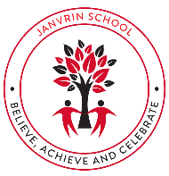  JANVRIN SCHOOL  Spring Term (1)  Dear Parents and Carers,  Happy New Year! We hope you had a lovely Christmas.  What an exciting term we have ahead of us! Below are a few reminders for this half term.  PE:  PE days continue to be on Wednesdays and Thursdays, so please ensure your child(ren) comes into school in their PE kit on those days.  Homework:  Homework expectations will also be staying the same. Reading, Maths and sound work will be given out on a Friday and should be returned the following Friday. Please ensure that you are filling out the Reading Log every week so that we know how your child is getting on with the reading book at home.  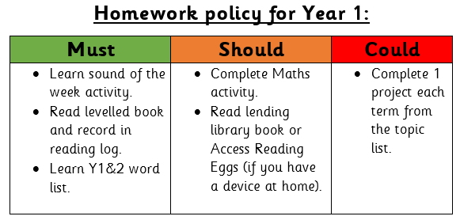  Thank you for your continued support!  Year 1 Team. | Topic Overview- Moon Zoom  This half term, everything is space related! We’ll travel through space to learn about the Solar System! We will be talking all things Neil Armstrong, learning poems about space and designing our own moon buggies to travel to space on!  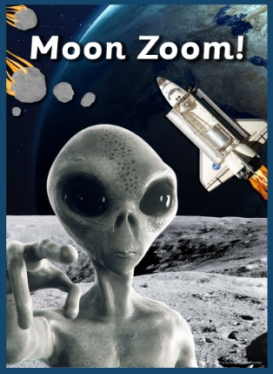  Topic books that we will be reading:  -Neil Armstrong, Little People, Big Dreams  -Beegu by Alexis Deacon  -Going to the volcano by Andy Stanton
Mathematics | ENGLISH
We are continuing with the Maths No Problem scheme. As mathematicians we will be learning about addition and subtraction within 20, shape and patterns and height and length. We will be using mental maths strategies, our knowledge about number place value and the relationship between addition and subtraction. We will finish the term learning about numbers up to 40! | Reading sessions  In reading this half term we will be looking at a variety of fiction and non-fiction books about Space. We will also be focusing on stories related to Neil Armstrong.  Key writing skills to be covered this half term:  - Poetry (rhyming)  - Non-Chronological Report (Fact File)  - Story retell about an alien
P.S.H.E | Science
In PSHE this half term we will be learning about living in the wider world, learning about rules within the community and identifying people and professionals who help us. We will look at how to care for people, animals and other living things, as well as looking after our environment. | In science we will be working scientifically to investigate sound. We will be investigating by carrying out tests and undertaking observations to understand different ways in which sound is made. We will be describing what kind of sounds they are (soft, loud) and discussing the pitch too. Lastly, we will be creating in pairs our own body percussion to perform to the class.
History | R.E
In History we will look at evidence that suggests that Neil Armstrong went to the Moon. We will look at old and new aircrafts/rockets and discuss their features before ordering them from oldest to newest. We will have a debate about why Neil Armstrong went to the Moon and whether he risked his life doing this or whether it was safe. We will go on to talk about how the astronauts got to the Moon and back safely. To finish, we will be answering the question “would you take a golden ticket and go to the Moon, or would you say no?”, giving reasons for our answers. | In R.E this half term we will be focusing on Judaism. We will be looking at what is special to Jewish people. We will the look at how Jewish people celebrate special occasions, such as Shabbat, and why they celebrate this. We will discuss what a Mezuzah is, what it reminds Jewish people of and then we will design our own.
Music | Art & D. T
In music this term we shall be starting the basics of reading music and understanding the difference between crotchets and quavers. We shall learn how to draw them and clap their rhythms and play musical games to learn about notes. We shall also celebrate the lunar new year with Chinese music and fan dancing. | In Art we will be focusing on an artist named Julie Perrot  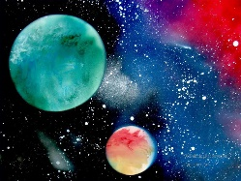  and creating some space art, just like hers!  In D.T we will be exploring, designing, and creating our own moon buggies in line with our space topic.
P.E | Computing
This half term, we will have a continued focus on the development of key object control skills, such as: throwing, catching, kicking and striking. We will be applying these skills in a range of fun and energetic games. We will continue to develop our gymnastic skills through the learning of various body rolls and balances. We will continue to explore different set ups of apparatus. | As junior programmers we will carry on applying the skills learnt in Autumn term, understanding algorithms. We will also be using a drawing software like Brushes Redux to create alien characters.

