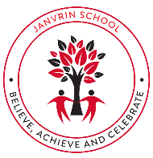  JANVRIN SCHOOL  Spring Term (1) 2026  Dear Parents and Carers,  Welcome back and a Happy New Year to everyone.  We have lots to look forward to this term. We will be helping the children to work hard to ensure that they achieve their full potential in all areas.  Working within Year 2, our team this term are Miss Allen, Miss Watson, Miss Gomes and Miss Irwin.  With regards to homework, we hope that children will read for 10 minutes every evening, with an adult so they can be asked questions about their story. They also have access to Times Tables Rockstars in order to practise their times tables for their weekly timetable tests.  Our topic for this half term is ‘Stories around the World’  Please let us know if you have any questions.  As always, it’s important for reading books and reading logs to be brought into school every day. | 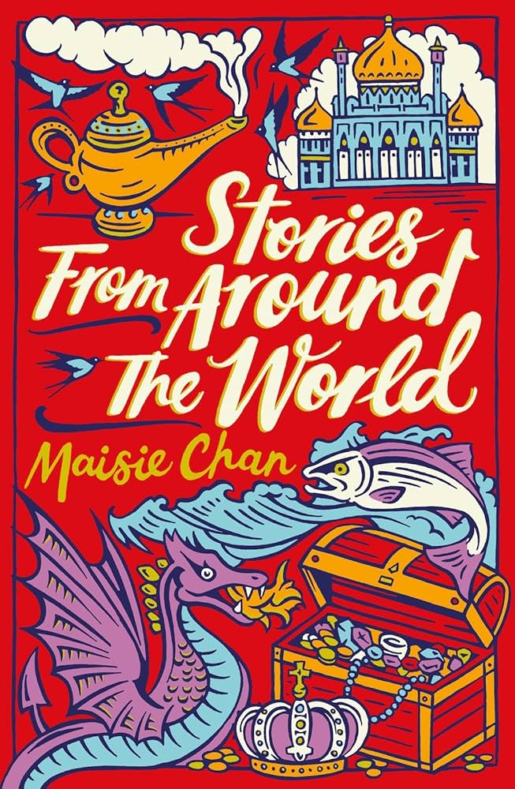  Stories from Around the World  Topic Overview  Buckle in as we travel around the globe finding out all about different countries around the world. We will learn all about features of different countries around the world, celebrations from around the world and look at different famous stories.
Mathematics | English
In Maths, we will be learning about measurement. We will learn about Temperate, Handling Data (Pictograms), Word Problems and the start of our fractions topic.  We will be applying our mathematical knowledge and skills through problem solving which will help develop reasoning skills. | In Reading this half term, we will continue to help children develop their reading fluency and confidence. We will also be working on comprehension skills by reading a wide variety of texts, discussing and asking the children questions about what they have read.  Key Writing Skills to be covered this half term:  - Narrative  - Poetry  - Information texts.
P.S.H.E | Science
Living in the Wider World  We will be looking at how we can make a kind, happy respectful community. We will also focus on how we share similarities and differences with people in our communities and we have to be respectful of these similarities and differences. | Our Science for this half term will focus on the difference between things that are living, non-living and dead. We will look at how we know when something is living, the difference between flowering and non-flowering plants and animal classifications.  We will be using oracy to enhance our Science learning throughout our sequence of learning.  Oracy Fab Finisher: Expert Talk  Audience: Older class in school  Purpose of talk: to gather and share information
French | R.E
N/A | Islam  This term we will be going back to our topic on Islam. We will be looking at two of the 5 pillars of Islam and what they mean to Muslims. We are hoping to organise a
Music | Art & D.T
  In music we shall be focussed on the basics of reading music. Learning about the notes on the stave including crotchets, quavers, minims and semibreves. We will do this through games and practical activities developing our skills in music. We shall start to learn to play the glockenspiel following a simple score. We will also celebrate the lunar new year making music | In Art, we are going to be discovering street art! We will look at the work of Banksy, a famous street artist and discussing how he creates his art. We will also discuss whether his work is graffiti/vandalism and if he/she should do it or not.
P.E | Computing
This half term, we will have a continued focus on the development of key object control skills, such as: throwing, catching, kicking and striking. We will be applying these skills in a range of fun and energetic games. We will continue to develop our gymnastic skills through the learning of various body rolls and balances. We will continue to explore different set ups of apparatus. | This half term we will be working with Mr Livesey to develop our computing skills on a laptop. We will learn how to login safely with our personal login details. We will also be learning about how to use a search engine like Google.  We will also be considering aspects of digital safety particularly how we keep ourselves safe online. We will be looking at collecting and using data safely.
Geography | History
In Geography we will be looking at human and physical features of the environment. We will compare St Helier with towns in other countries, looking at the features they have in common and what is different about the locations.

