Year Group | Talk Tactics and Groupings | Sentence Stems | Opportunities for Oracy at Janvrin
EYFS  At this stage we have put emphasis on our pupils’ fundamental oracy skills such as speaking loud enough to be heard, asking and answer questions, beginning to join ideas together and taking turns. We use our environment and teacher modelling to focus on vocabulary development and to build confidence in speaking. |   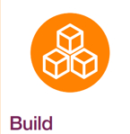  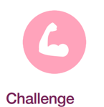    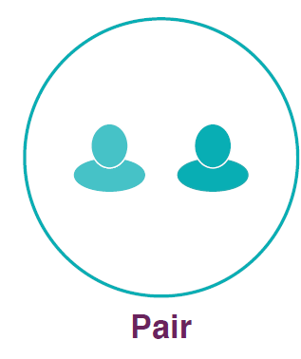  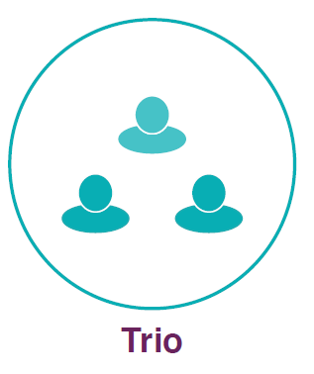 | “I think…”  “Yes, and…”  “I disagree…because…” | - Reception Graduation Assembly.  - Christmas Performance.  - Presentational Talk Focus Week.  - Helicopter stories.  - Poetry Basket.  - Drawing Club.  - ‘All About Me’ book.  - Investigations.  - Following pupil interests.  - Singing independently.  - Copy vocal modelling.  - Nativity Performance.  - Role plays.  - Talking to visitors.  - Wellcomm interventions.  - STEM Morning.  - Culture Day.  - Word Aware.  - Rap.  - Makaton.
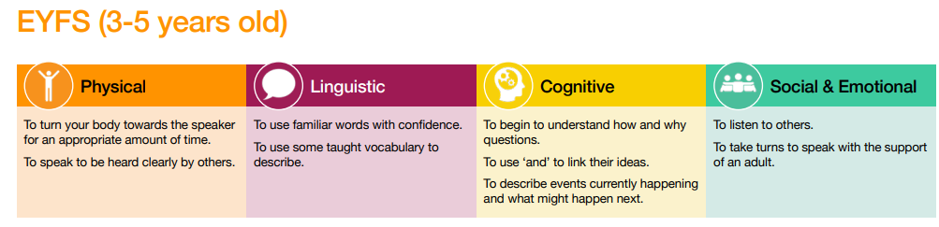

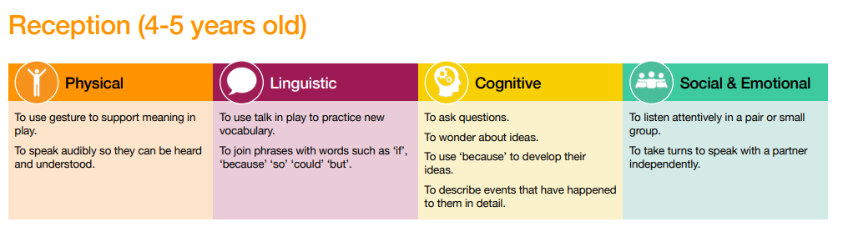

Year 1  We continue the strong base developed in EYFS but incorporate additional structures to plan and teach high-quality oracy linked to new curriculum. At this stage, we continue to use our environment and teacher modelling to develop speaking skills and confidence, whilst building new vocabulary. |  | “I think…”  “Yes, and…”  “I disagree because…”  “I agree because…” | - Christmas Show.  - Copy vocal modelling.  - Star of the Week.  - Hot seating.  - Story retelling.  - Paired or small group discussions.  - Swap within Year 1.  - KS1 Assemblies.  - Flipped Parent Consultations (Spring Term).  - STEM Morning.  - Culture Day.  - Liberation Day.  - Visitor discussions e.g. heritage, zoo and fireman.  - Reading to others.  - Project presentations.  - ECOF reading.  - Fab Oracy Finishers.
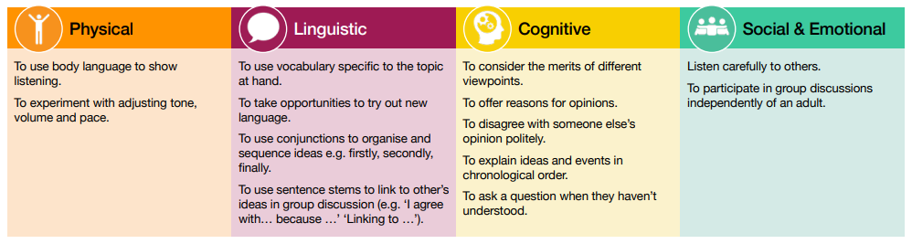

Year 2  At this stage we build upon the strong start given in EYFS and Year 1 and put emphasis on beginning to have more self and audience awareness, considering which language is appropriate and thinking about speech being structured and purposeful. Vocabulary continues to be a focus, with curriculum planning demonstrating a progression in Tier 2 vocabulary. | 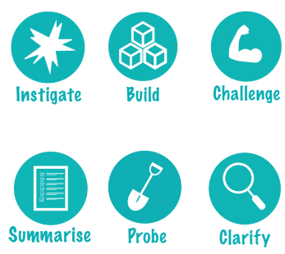   | “I think…”  “Yes, and…” “Building on X’s idea…”  “I disagree because…”  “I agree because…” | - Christmas Show.  - Copy vocal modelling.  - Topic Exhibitions.  - Asking questions to visitors.  - Trips.  - Reading Vote  - Oracy Experts.  - Flipped Parent Consultations (Spring Term).  - Peer feedback opportunities.  - STEM Morning.  - Culture Day.  - Boardroom Editing.  - Liberation Day.  - Fab Oracy Finishers.
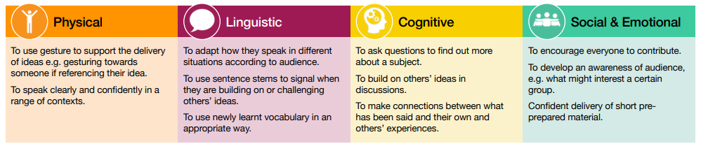

Year 3  At this stage, to build upon Key Stage 1 and EYFS, we have put the emphasis on adapting to different situations and audiences, tailoring speech to a particular audience and being more aware of group dynamics and how to influence these. Pupils appraise each other’s oracy skills using the oracy framework. Children develop confidence in speaking and listening in a range of group scenarios. |   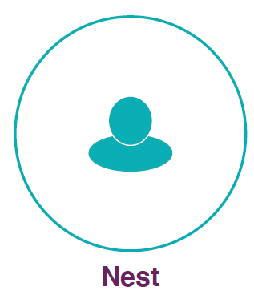  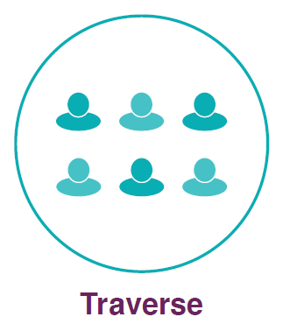 | “I would like to start by saying…”  “Building on X’s idea…”  “I disagree because…”  “Our discussion focused on…”  “Why do you think…” | - KS2 Assemblies.  - Choral Poetry Performances for Eisteddfod.  - Copy vocal modelling.  - KS2 Enterprise Project.  - Flipped Parent Consultations (Spring Term).  - Trips.  - Children’s Day.  - Careers Fair.  - Science Day presentations.  - Exhibitions.  - Eco-Club.  - Peer feedback opportunities.  - STEM Morning.  - Culture Day.  - Boardroom Editing.  - Liberation Day.  - Fab Oracy Finishers.
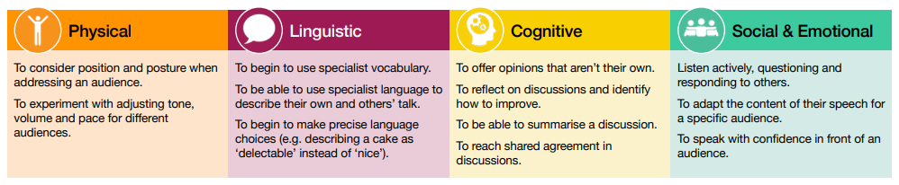

Year 4  At this stage, to build upon Key Stage 1 and EYFS, we have put the emphasis on adapting to different situations and audiences, tailoring speech to a particular audience and being more aware of group dynamics and how to influence these. In Year 4 we start to introduce more unfamiliar audiences for the children to speak in front of, whilst building upon the learnt skills in previous year groups with increased vocabulary complexity. |  | “I would like to start by saying…”  “Building on X’s idea…“I agree and would like to add…”  “I disagree because…” “To challenge you X, I think…”  “Our discussion focused on… “So far we have talked about…”  “Why do you think…” “Can you provide and example…” | - Debates.  - Springboard tasks across a range of subjects.  - Copy vocal modelling.  - Poetry Performances.  - Drama opportunities.  - Topic Exhibitions.  - Presenting research (River Project).  - KS2 Assemblies.  - KS2 Enterprise Project.  - Flipped Parent Consultations (Spring Term).  - Peer feedback opportunities.  - STEM Morning.  - Outdoor Club.  - Culture Day.  - Boardroom Editing.  - Liberation Day.  - Fab Oracy Finishers.
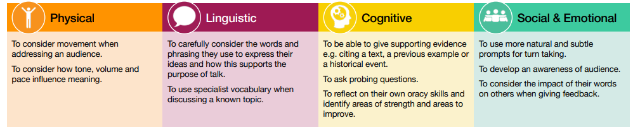

Year 5  At this stage we have put the emphasis on adapting to different situations and audiences, tailoring speech to a particular audience and being more aware of group dynamics and how to influence these. A focus on higher level vocabulary builds on the prior learning of previous year groups to add greater sophistication to speech. Further opportunity for speaking to unfamiliar audiences and questioning visiting speakers is given through activities such as the States Chamber debate, and welcoming visiting speakers into class. Peer Mediation training begins in Year 5, giving additional opportunities to hone oracy skills. | 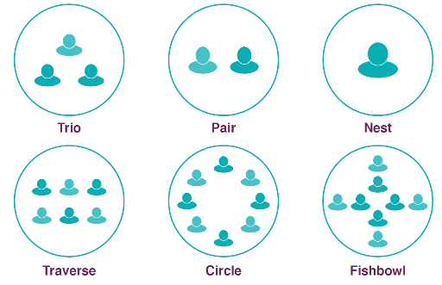 | “I would like to start by saying…” “We haven’t yet talked about…”  “Building on X’s idea…“I agree and would like to add…”  “I disagree because…” “To challenge you X, I think…”  “Our discussion focused on… “So far we have talked about…”  “Why do you think…” “Can you provide and example…”  “So are you saying…” “Does that mean…” | - States Chamber Debate  - KS2 Enterprise Project.  - French Experience.  - Poetry performances.  - Residential Trip to Crabbe.  - KS2 Assemblies.  - Year Group Choir.  - Young Interpreters.  - Flipped Parent Consultations (Spring Term).  - Topic Exhibitions.  - Crabbe Presentations.  - Hot seating and role plays.  - Peer feedback opportunities.  - Peer Mediation.  - STEM Morning.  - Culture Day  - Boardroom Editing.  - Liberation Day.  - Fab Oracy Finishers.
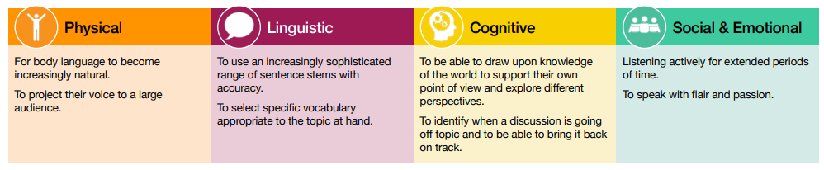

Year 6  At this stage we have put the emphasis on adapting to different situations and audiences, tailoring speech to a particular audience and being more aware of group dynamics and how to influence these. A focus on higher level vocabulary builds on the prior learning of previous year groups to add greater sophistication to speech. Skills of appraising oracy are honed, using the language of the framework to develop each other’s language skills. Opportunities to present in a ‘high stakes’ environment through the JBs Burger Challenge and Speak Up Speak Out are given to enhance pupil’s opportunities to speak in-front of unfamiliar audiences for a given purpose. |  | “I would like to start by saying…” “We haven’t yet talked about…”  “Building on X’s idea…“I agree and would like to add…” “X’s idea made me think…”  “To challenge you X, I think…” “I understand your point of view but have you thought about…”  “Our discussion focused on… “So far we have talked about…”  “Why do you think…” “Can you provide and example…”  “So are you saying…” “Does that mean…” “Can you clarify what you mean?” | - Speak Up Speak Out Jersey Challenge.  - KS2 Enterprise Project.  - KS2 Assemblies.  - Residential Trip to Crabbe.  - Mental Health Ambassador training and whole-school support.  - Young Interpreters.  - Debates.  - Christmas Poetry Recital.  - Hot seating and role plays.  - Leavers Assembly and Show.  - Flipped Parent Consultations (Spring Term).  - Topic Exhibitions.  - Asking questions to visitors.  - Peer feedback opportunities.  - Culture Day.  - Boardroom Editing.  - Liberation Day.  - Book Buddies.  - Choir.  - Fab Oracy Finishers.


