Janvrin School

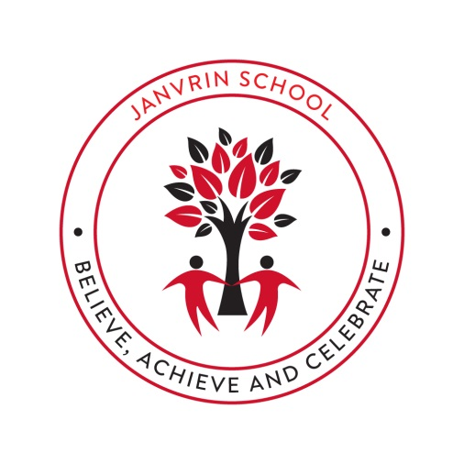

Oracy Policy

Introduction:
At Janvrin School, oracy (speaking and listening) plays a vital role in the teaching and learning. The ability to listen actively, speak clearly and communicate effectively with others is seen as a fundamental part of the learning process. Oracy is a central part of any future career and allow us to live within our society successfully. Within school, oracy underpins the development of reading and writing, and is key in progress in all subject areas.
Janvrin’s Oracy Vision:
“Every child develops the confidence and skills to communicate clearly, listen respectfully, and use talk to deepen their learning. Pupils leave Janvrin with a strong voice, ready to flourish in secondary school, in their communities, and in the wider world.”
Curriculum coverage and progression:
Curriculum Intent Statement:
At Janvrin we believe that every child deserves to develop a confident voice. Inspired by the work of Voice 21, we recognise oracy as a fundamental part of literacy and a vital tool for learning, wellbeing and future success. Therefore, we place talk at the heart of our curriculum so that all pupils, regardless of background, can articulate their ideas clearly, listen actively, and engage meaningfully with others.
The Jersey Curriculum for English reflects on the importance of spoken language in pupils’ development.
Oracy is embedded throughout our broad and balanced curriculum and is explicitly taught by all teachers. Lessons are talk-rich, questions are carefully planned to ensure all pupils can participate and talk opportunities are carefully planned and scaffolded. We plan for exploratory and presentational outcomes, outlined within our Oracy Curriculum Long Term Plan.
Year groups will be taught specific oracy skills and talk tactics, see within our Oracy Skills Progression Document.
Planning and Teaching of Oracy:
Our Science, PSHE and RE curriculum is a key focus at Janvrin, in terms of planning and teaching the key concepts and understanding through an oracy-based sequence of learning. We want our explicit and purposeful talk opportunities in each lesson to be able to harness and elevate their learning. Oracy tasks, groupings, talk tactics and framework strands will be outlined on the Medium-Term Planning for each of these focused subjects.
Planning and teaching oracy will also be encouraged within all other subjects to enhance learning and develop their speaking and listening skills. All pupils will work towards an oracy ‘Fab Finisher’ each half term within a range of subjects (see Oracy LTP).
All teachers must add oracy icons onto their teaching resources to ensure it is planned and explicit for the teachers and pupils in lessons. Teachers must provide regular opportunities for pupils to reflect on their oracy skills and oracy skills of others using Talk Detectives.
Assessment and Recording:
At Janvrin Primary we use the Oracy Framework that was developed by the University of Cambridge and Voice 21. This framework is split into 4 strands:
- Physical
- Linguistic
- Cognitive
- Social and Emotional
This framework allows both staff and pupils to understand what makes good spoken communication. It enables successful discussions with inspiring and effective communication. The framework is to be used by staff to give feedback, targets and assess progress. Pupils will use the framework to self-assess, peer-assess and set them goals.
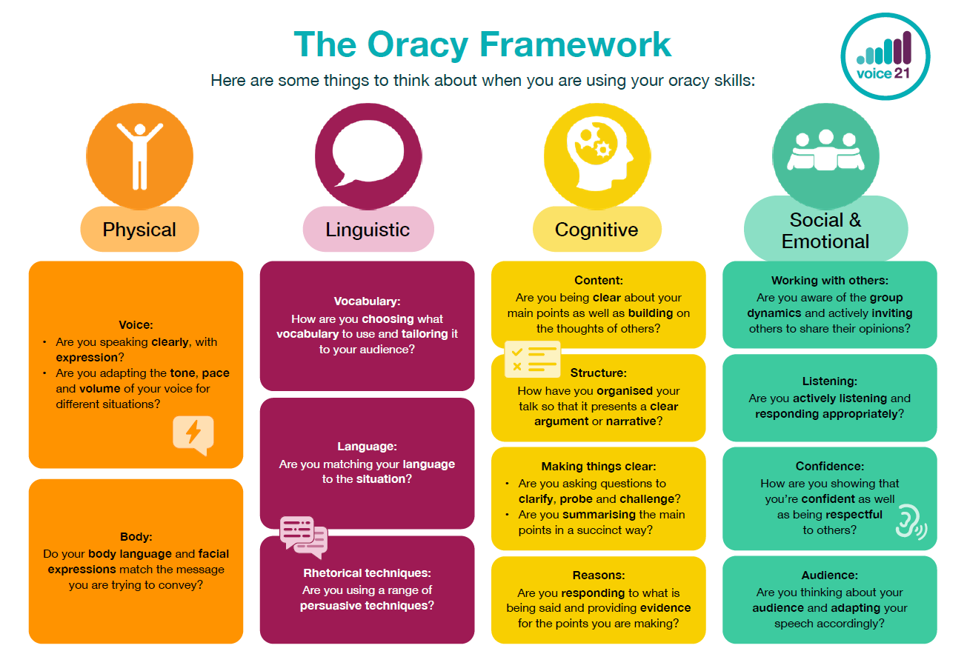

Monitoring:
The Oracy Subject Lead will carry out termly monitoring of planning and learning (specifically Science, RE and PSHE). This will involve working closely with Subject Leads in how to elevate their subject using oracy. Within the academic year, the lead will conduct Listening Walks, Pupil Discussions with champions and Book Looks (RE and PSHE floorbooks, as well as other subjects).
Inclusion and equal opportunities:
Inclusion is at the heart of our oracy intention; all pupils are given the support and opportunities they need to thrive in this subject. Pupils with speech and language barriers will develop their oracy skills through practise and an embedded oracy curriculum. Pupils with additional needs are encouraged to actively participate in oracy opportunities. Our aim is to develop the confidence of all our pupils, which for some pupils this may manifest in different ways, alongside the Oracy Progression Document from EYFS to Year 6. We hope for all our learners to be more confident and effective communicators, emotionally and academically as they progress through the school.
We are a Rights Respecting School and we ensure that all our pupils rights are upheld. This policy supports Article 12 and 13 from the UN Convention of the Rights of a Child.
Article 12: Every child has the right to express their views, feelings and wishes in all matters affecting them, and to have their views considered and taken seriously.
Article 13: Every child must be free to express their thoughts and opinions
Roles and Responsibilities:
- All staff will work together to ensure the implementation of the Oracy Policy and Consistencies Document (see Appendix 1 below).
- Staff will nominate an ‘Oracy Winner’ each half term from each class linked to the specific focus strand from the framework.
- The Oracy Lead will be responsible for the monitoring of curriculum coverage and the impact of planning and teaching oracy within subjects.
- The Oracy Lead will provide feedback and training to staff to ensure consistency, celebration, and quality.
- The Oracy Lead will work alongside other Subject Leads to ensure the incorporation of planned teaching and learning of oracy.

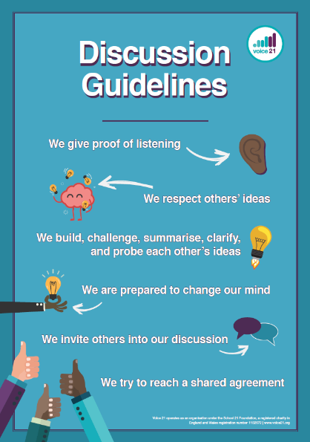
Displays and Resources:
All classrooms should have useful, purposeful Voice 21 resources visible for the staff and pupils.
All classrooms must have agreed class Discussion Guidelines and Targets (linked to the Oracy Framework).
Establishing and reinforcing Discussion Guidelines enables safe, effective and respectful talk environments. Identifying specific targets for the class allows for a collective oracy focus and opportunity for assessment. These can be changed half termly or termly.

Listening Wheels – sets out various listening skills and visuals for each one. It can be used to support students to reflect on their discussion, to set high expectations and targets for listening. These wheels are varied depending on age.
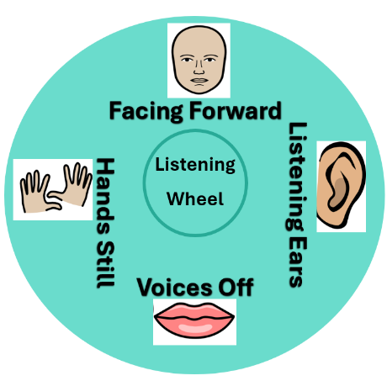
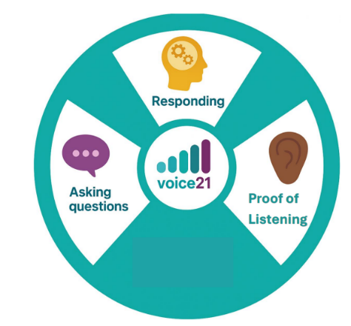
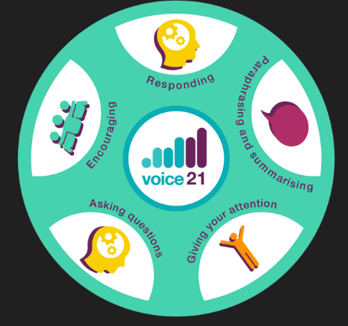
KS1 Wheel
EYFS Wheel
KS2 Wheel
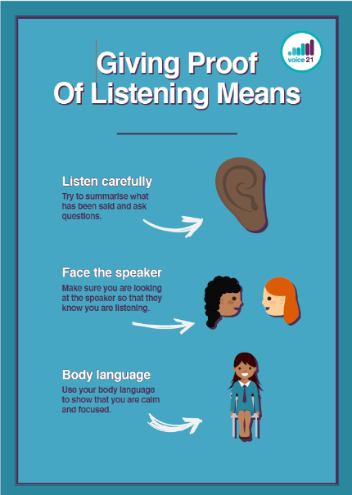
Proof of Listening – clearly identifies the key elements to show proof of active listening. These can be reinforced with actions and repetition.

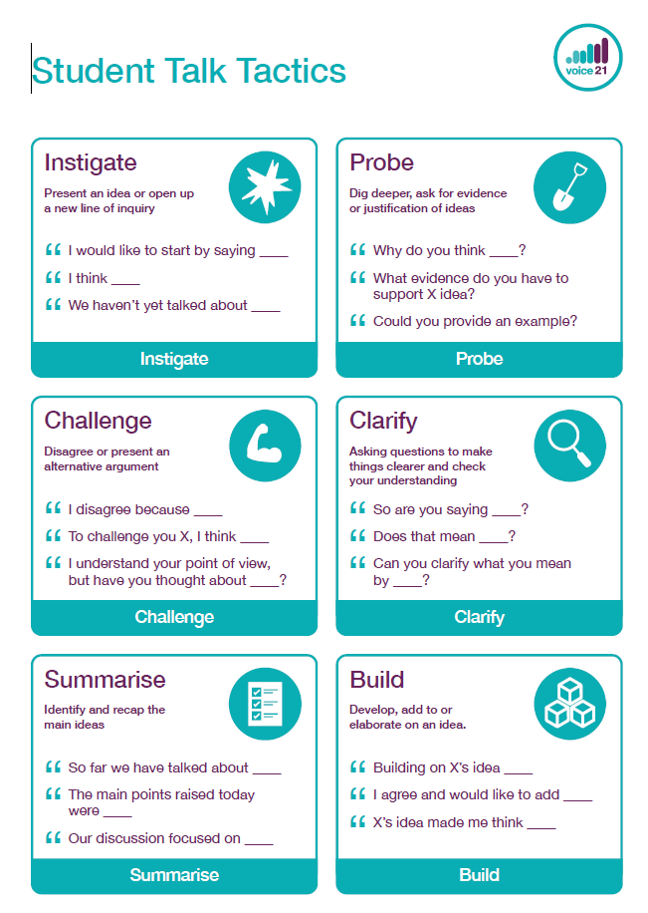
Student Talk Tactics – this outlines the key structures needed within discussions. Pupils are familiar with and encouraged to take on different talking roles and use the sentence stems to develop clarity, purpose and structure to their speaking and listening skills.

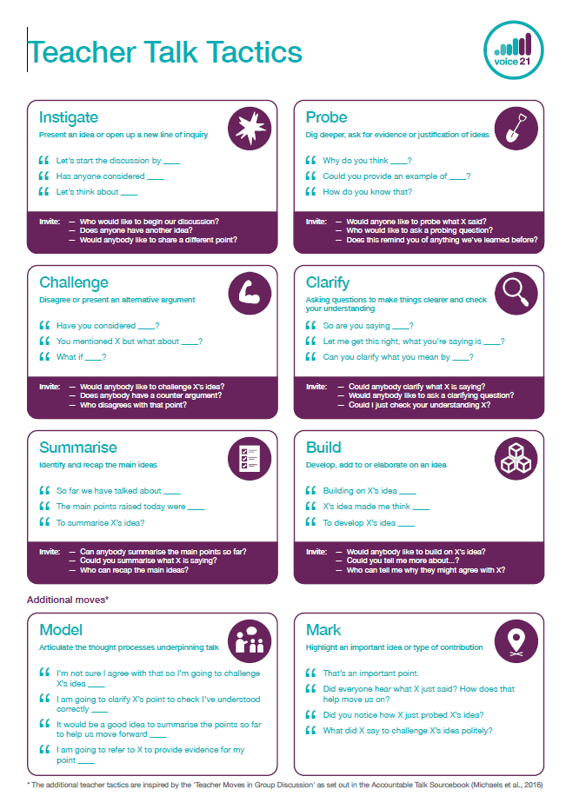
Teacher Talk Tactics – these outline all the modelled structures to scaffold classroom discussions, promoting educationally productive talk. Teachers have two additional tactics to employ in order to foster high-quality talk for learning.

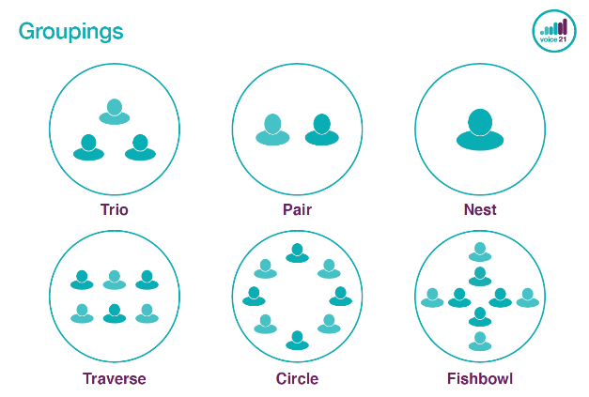
Groupings – having different groupings provides a planned management within talk opportunities and provide the support within discussions and aid the development of both speaking and listening, encouraging them to become more active listeners.

Appendix 1

Oracy Consistencies (Voice 21 Partnership)
1. Talk Roles & Group Discussion
- Consistent use of talk roles and actions (e.g. builder, challenger, clarifier, summariser).
- Visual prompts in every classroom (posters, table cards).
- Children can explain what the roles mean and use the associated sentence stems confidently.
2. Sentence Stems & Oracy Framework
- Sentence stems for reasoning, agreeing, disagreeing, and clarifying are displayed and used across subjects.
- Teachers explicitly model them, and children are expected to use them in all lessons (not just English).
- Oracy framework (physical, linguistic, cognitive, social-emotional) referenced in planning and feedback.
- Teachers evaluate appropriate time to encourage pupils to innovate sentence stems to stay fresh and progressive.
3. Routines for Talk
- Think–Pair–Share and No hands up (teacher selects speakers) used consistently.
- Listening wheels or clear expectations for active listening reinforced across year groups.
- Every child expected to contribute to pair, group, or whole-class talk.
4. Feedback & Reflection
- Time built into lessons for pupils to reflect on the quality of their talk ("How well did we listen?", "Did we build on each other’s ideas?").
- Teachers use oracy-based success criteria as part of learning objectives.
5. Whole-School Culture
- Shared oracy-rich assemblies (children leading, presenting, and questioning).
- Consistency of expectations in corridors, playground, and dining hall (respectful talk, turn-taking, manners).
- Staff trained to use oracy language in behaviour and learning conversations.
6. Progression & Inclusion
- Oracy progression framework mapped across year groups, so skills build year-on-year.
- Scaffolds for EAL and quieter pupils (sentence frames, visuals, pre-talk opportunities).
- Celebration of oracy through events (debates, poetry recitals, performance assemblies).
7. Parental & Community Links
- Parents informed about oracy expectations (through newsletters, parents evening, reports etc).
- Children encouraged to use oracy skills at home and in the community.

