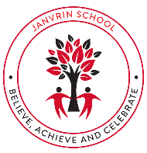  JANVRIN SCHOOL  Summer Term 2026  Dear Parents and Carers,  We have lots to look forward to this term. We will be helping the children to work hard to ensure that they achieve their full potential in all areas.  Homework will follow the same format as last half term.  Your child will receive a worksheet linked to Maths and a worksheet (usually) linked to Writing. These will both be familiar activities, linked to what we are currently learning in class. Homework will be handed out on a Friday and is due in for the following Friday. We also recommend accessing online learning resources such as: Rollama and TTRS. Your child should have their own individual logins for all of these but please ask your class teacher if these need to be sent out again.  We are planning on carrying out an Exhibition linked to our new topic ‘Flow’ which will take place on the afternoon of Thursday 21st May. Similarly to last term, the children will be expected to create a home-learning project linked to our topic. There will be ideas added to Google Classroom by your child’s class teacher. This time, the exhibition will be exclusively for other classes within the school to visit and enjoy.  Many thanks,  Year 3 Team | Flow  Topic Overview  This engaging and dynamic theme will explore the wonders of movement, energy and natural systems. Students will dive into the science of water, the fascinating journey of rivers, and the importance of conservation in our environment.  Throughout this topic, students will:  - Explore Water Cycles  - Investigate Rivers and Streams  - Focus on Conservation  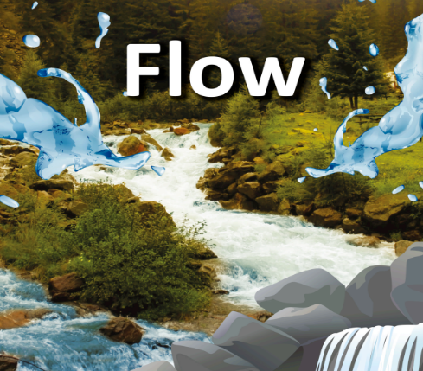  Through hands-on activities, experiments and cross-curricular links, students will develop a deeper understanding of the natural world around them. They will also have opportunities to practice their oracy skills through critical thinking, problem-solving, and teamwork to investigate these essential concepts.
Mathematics | ENGLISH
As mathematicians we will be learning how to apply our knowledge and skills through problem solving which will help develop reasoning skills. Our focus will be on:  - Angles  - Lines- parallel and perpendicular  - Shape- Measuring and calculating the perimeter.  These are both large and in-depth topics.  There are lots of online games for children to play at home to support their learning at school. | Key Skills to be covered this half term:  - Narrative writing  - Nonsense poem linked to “The Jabberwocky”  The new text drivers we are focusing on are:  -Just a box by Joseph Coelho  -The Jabberwocky (video)  Guided Reading –  This term our focus text is The Sheep Pig. Through this book, children will have regular opportunities to engage in rich discussion, developing their comprehension skills in line with the Year 3 curriculum.  They will be supported to make predictions, retrieve key information, and draw inferences and justify their thinking using evidence from the text. Children will also explore vocabulary in context, build understanding of characters and themes, and practise summarising key events to deepen their understanding of the story.
Computing | Science
Desktop Publishing  Year 3 pupils will be introduced to desktop publishing and how text and images can be combined to communicate ideas. They will use publishing software to edit and improve documents, making thoughtful choices about font style, size, and colour. Children will also learn about templates, page orientation, and placeholders, using these tools to design their own magazine front cover. Along the way, they will explore different layouts and consider how desktop publishing is used in everyday life. | Plants  The children will be focusing on plants. The unit will begin by learning about the different parts of the plants and their functions. The children will have the opportunity to label diagrams and observe using real plants. We will look at how water is absorbed and take part in various scientific experiments as well as explore the roles of flowers within plant reproduction.
Languages | R.E
As linguists we will be developing our vocabulary and building the phrases we can use. In French, we will be learning about different fruits. This will link to the ‘Hungry Caterpillar’ Book which I am sure all children are familiar with. We will start off by learning the names of fruits and colours, then the children’s opinions will follow. There will be some opportunities for roleplay and games.  This term, we have been lucky enough to have a special visitor named Charlie in class each week to teach the children Jerrais! | Christianity – Gospel  The children will be identifying texts that come from a Gospel, which tells the story of the life and teaching of Jesus. The children will be giving examples of how Christians try to show love for all and how leaders try to follow Jesus’ teaching in different ways.
Music | Art & D.T
In music we shall begin with playing the Ukulele and learning to strum some basic chords. We shall then explore the art of Foley (sound effects) and Mickey mousing (musical sound effects). We will need to choose the correct items to make the perfect sound and have great timing and teamwork. It requires immense concentration and creativity. | This half term we will be focusing on the artist Claude Monet. The lessons will follow the same format where the artist is researched to find out about them and their style of work. Then we will focus on his artwork of the pond and lily pads. The children will use pastels to practice creating the water and blending dark and light shades to show reflection and ripples. Tissue will also be used to create the lilies by balling and layering leaves. This will support with the final piece created.
P.E | P.S.H.E
This half term we will continue to develop a range of object control skills, including: throwing, catching, kicking and dribbling. We will also continue to apply skills in modified versions of games such as ‘Basket tag ball’ and ‘Hoopball’. | In PSHE this half term, our focus will be on health and well-being! We will be looking at the choices that people make in daily life that could affect their health focusing on both physical health as well as mental well-being. We look at positive and negative influences and identifying healthy and unhealthy choices in relation to both food and sleep.

