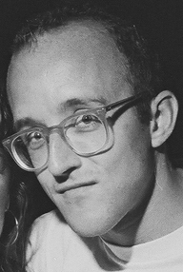
Keith Haring

Task - research about Keith Haring.
- Who is he?
- When was he born?
- What is he known for?
- Find facts about his life/work.

Task 2 – Create a poster/fact file about Keith with the information you have found.

Task 3 – To create your own piece of Art work in the style of Keith Haring.

