Time – lesson 8
Use a timer ad see how many times you can clap in 15 seconds.
You could use a stopwatch on a mobile phone, Ipad/tablet or computer.

Activity time
See who can clap the most in 15 seconds.
You can play with your sibling or parent if they have a moment. If not time yourself and see if you can beat your record.
Who clapped the most in the 15 seconds?

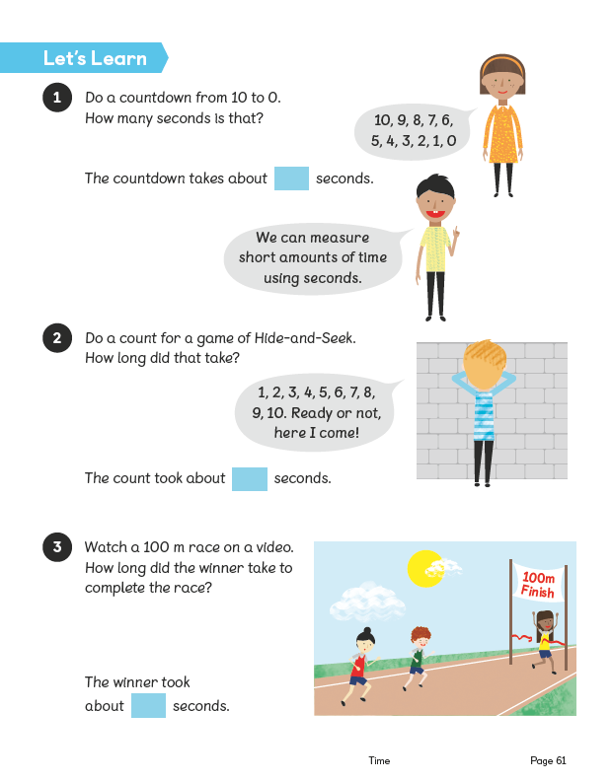

Here is a link to a 100m race
https://www.youtube.com/watch?v=XxOoPEhy9T8
How long did the race take?

Activity time!
If you are able to complete. Do not worry if you can’t.

Now practice…
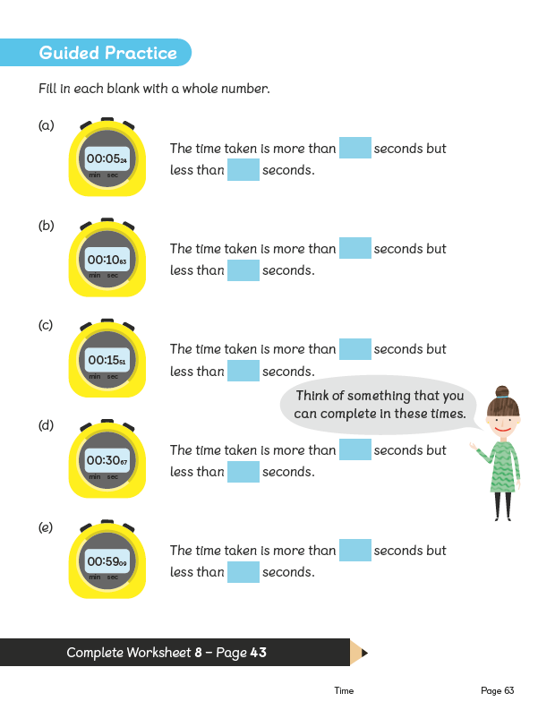

Now complete the worksheet below.
